Use find homography to find the perspective transform of the object in the target image, at least four correct points are needed

First use SIFT and ratio test to find best matches, min match count here is 10

If enough are found then we find the perspective transform matrix using these matching points and use it to transform the corners of the query image to the points in the train image

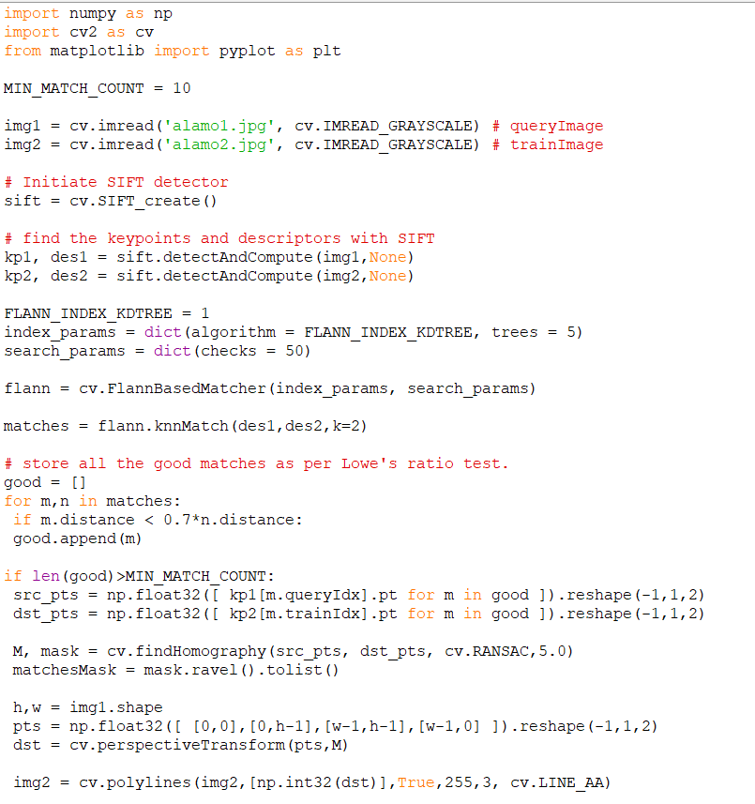

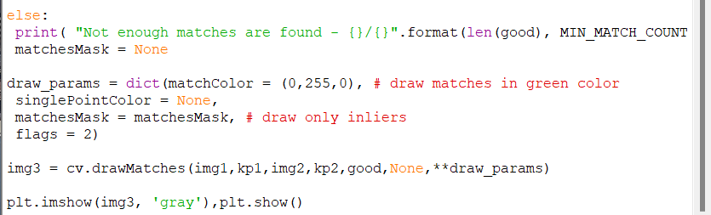

REsults